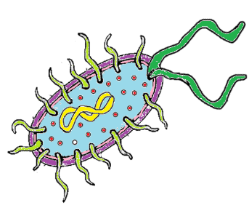
Foodborne Illnesses
Guide to Good Food, page 116

NAME________________________________________ DATE______________________ PERIOD_____
DIRECTIONS: Define the following terms.
- Contaminant: a substance that may be harmful that has accidentally gotten into food
- Microorganism: a living substance so small it can only be seen by a microscope
- Bacteria: single-celled or noncellular microorganisms; lie almost everywhere; not all harmful; some types of harmless bacteria are normally found in foods.
- HACCP: system requires looking at food production processes to see where possible hazards could occur
DIRECTIONS: Complete the following chart using Guide to Good Food page 116. Draw illustrations in the Food Source column to complete the chart.
FOODBORNE ILLNESSES
ILLNESS | FOOD SOURCES  (Include pictures) | SYMPTOMS
Botulism |  | Double vision, inability to swallow, speech difficulty. Progressive respiratory paralysis that can lead to death  Appear: _____ to _____ hours after eating
Campylobacteriosis |  | Diarrhea, abdominal cramping, fever, bloody stools  Appear: ____ to ____ days after eating  Last: ____ to _____ days
E. coli infection |  | Bloody stools, stomachache, nausea, vomiting  Appear: _____ to _____ hours after eating  Last: 4 to 10 days
Listeriosis |  | Fever, headache, nausea, vomiting  Appear: ____ to _____ hours after eating
Perfringens poisoning |  | Abdominal pain, diarrhea, possibly nausea and vomiting  Appear: _____ to _____ hours after eating  Last: ______ hours
Salmonellosis |  | Severe headache, nausea, vomiting abdominal pain, diarrhea, fever  Appear: _____ to_____ hours after eating  Last: _______ to ______days
Staphylococcal poisoning |  | Abdominal cramping, nausea, vomiting, diarrhea  Appear: 30 minutes to 8 hours after eating  Last: _____ to _____ days

