Steps to Food Safety Poster – 40 points - Teamwork
DATE______________________ CLASS PERIOD____
GROUP MEMBERS: 1. ______________________ 3. __________________________ 5. ____________________
2. ______________________ 4. __________________________ 6._____________________
DIRECTIONS: Your group needs to assign one of the following areas to each of your team members. Once established you will need to read from pages 117 to 123 of Guide to Good Food to gather data for your poster.
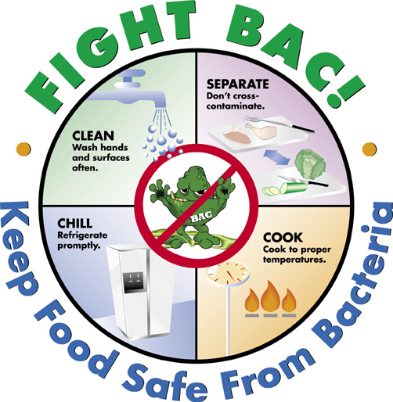
- CLEAN
- SEPARATE
- COOK
- CHILL
- COOKING FOR SPECIAL OCCASIONS
- EATING SAFELY WHEN EATING OUT; STORING FOOD FOR EMERGENCIES

The poster will be rated on each element using the scale listed below.
5 = Superb, usually excellent
4 = Evenly excellent
3 = Mostly excellent, 1 or 2 elements that are not excellent
2 = Better than poor, only 1 or 2 elements that are better than poor
1 = Evenly poor
0 = Not done or very poor

Rating Element
_____ 1. The theme of the poster is clear when you first look at it including a heading.
_____ 2. The information of the poster is inclusive, accurate, and related to the theme.
_____ 3. Spaces, shapes & colors make the poster more effective & easier to understand.(neat/presentable)
_____ 4. Pictures, drawings, or other similar devices help make the poster clear & more effective.
_____ 5. The text of the poster is clear, neat, clean and easy to read.
_____ 6. The format of the poster has followed the guidelines.
_____ 7. It is clear the students understand the course content related to the project.
_____ 8. The poster is creative and interesting.
_____/ 40 = Overall rating

